Joseph Roper

Salford City College

BTEC National 90 Credit Diploma in Creative Media Production

Unit 69: Concept Art

Unit 69 – Concept Art for Computer Games

# Concept Art

[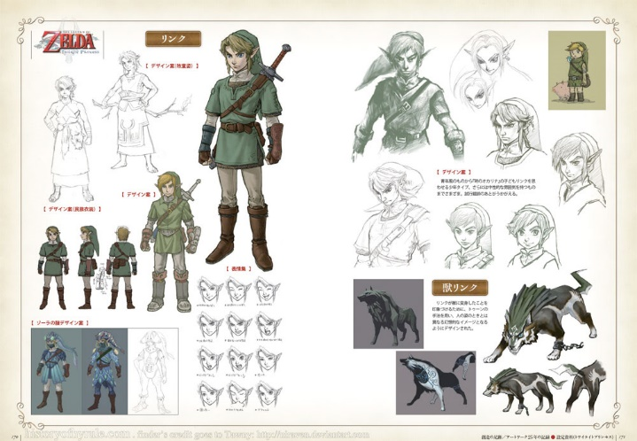](http://www.theconceptartblog.com/2012/05/07/hyhule-historia-zelda-25th-anniversary/)Concept art is used in pre-production to show ideas and in games design, it is mainly used to show the developers preliminary ideas for characters and enemies in the form of drawing. Concept art is also used in films, animation and well everything which contains drawings such as architecture. Concept art is just illustrations that convey an idea, mood, character, colour scheme and or the overall style of the game. Concept art starts off as rough sketches and with time they are revisited and perfected/optimised and left as final ideas and are usually released to the public.

As you can see this picture shows the early stages of concept art and the final design for the character Link in The Legend of Zelda: Twilight Princess. From the concept art, I can see that the colour scheme for the game will be quite dreary and dark through the use of dark green and brown used for Link’s clothing compared to his usual bright and colourful attire. This colour scheme will give off a gloomy atmosphere in the game making the game feel more realistic and grounded, setting the tone and the mood for the game instantly that this game in the series will not be as childish and carefree as the others.

# Visual Elements

The first stage in concept art is to start making different prototypes of the same idea but with little tweaks in every drawing until the artist is content and happy with the overall design and look of the artwork. The more variants an environment, character or weapon has during the concept art stage of development the more options the developers will have to choose from for the final design. The final design should fit the brief given by the developers stating what the look and feel of the art should be. The artwork should also resolve around the theme of the game chosen by the developers so that you don't get artwork for a goory horror game when the developers wanted to make a children's game.

An example of game concept art which demonstrates visual elements being changed throughout the same artwork is with the game The Last of Us. As you can see both images contain the same background and subject. In the first image the player is staring at a war-torn building with panels scattered around and broken plywood being used as a bridge to travel to the second floor reverting back to primitive technology reflecting the infected people going back to their ancient instincts and maliciously attacking anyone who comes near them. However, this upsetting tone and feel from the first image is uplifted with the second images addition of plant life to make it look like nature is taking over the building this making the player/viewer have hope for the future of the characters as there is still life growing throughout the world. This is also reflected upon the light coming from the torch when hitting the plant life creates a warmer colour making the player/viewer feel more comfortable relieving the tension from the situation the main characters are in which is an apocalyptic world over in with zombies.

An advantage of making multiple prototypes of the game’s art is that by the end of the prototyping stage the artist will have many different ideas to choose from for the final version. Whereas if the artist made less concepts they would struggle to decide the final design as they wouldn't have many options to work with. The disadvantage of making multiple concepts is that the artist could not really know what to do to improve the drawing and may end up adding useless additions that don't make the cut and just waste time and decrease productivity.

[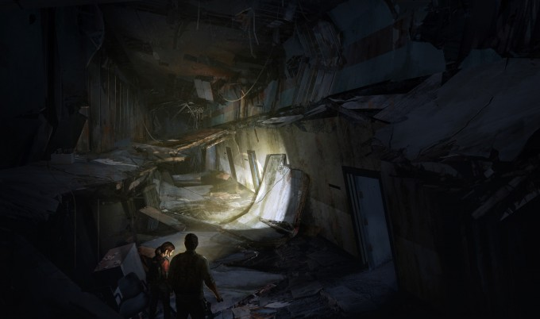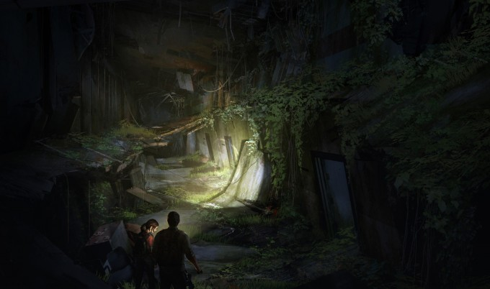](http://conceptartworld.com/news/the-last-of-us-concept-art/)

# Style

A games art style is decided at the beginning of the project and will be abided by throughout the rest of the project. There are many different art styles that have been developed and adapted throughout the years. Some examples of these unique art styles are exaggeration, realism and cartoon. The exaggeration art style is when an artist will embellish important or easily identifiable features on the character such as enlarging the head or eyes so that they will stand out more on paper. The exaggeration art style can be used for comedy for example with a character having a big head and a really small body the mis proportions add humour. The art style can also be used to have characters show more emotion with drawing enlarged eyes the viewer can become more attached to the character as the big eyes make the character seem friendlier and more open. Realism is used by artists to make very realistic drawings almost looking photographic. This art style is widely used in modern game concept art as more and more games are aiming for realism so the concept art must be realistic too. The cartoon art style allows for creative freedom making it a popular art style for beginners. The initial art style of concept artwork is important as it usually will not change throughout the project and will most likely be the final art style.

The Borderlands games have a unique art style that looks comic book esc with the thick black outline around the character emphasizing the tone and shape of the character. The exaggeration of the characters muscles makes him look more unique and stronger. The cel-shaded style also provides great colour depth on the character to make the antagonist seem grittier and fiercer like he has been scavenging for decades making him more rugged and evil.

Having a set art style early on in a games development will save time resulting in an increase of productivity as artists will have a clear style to follow for all of the game's assets and will not get confused on how something should look. Although having a set art style is good at the beginning of a project it also stops new ideas around the art style being implemented.

[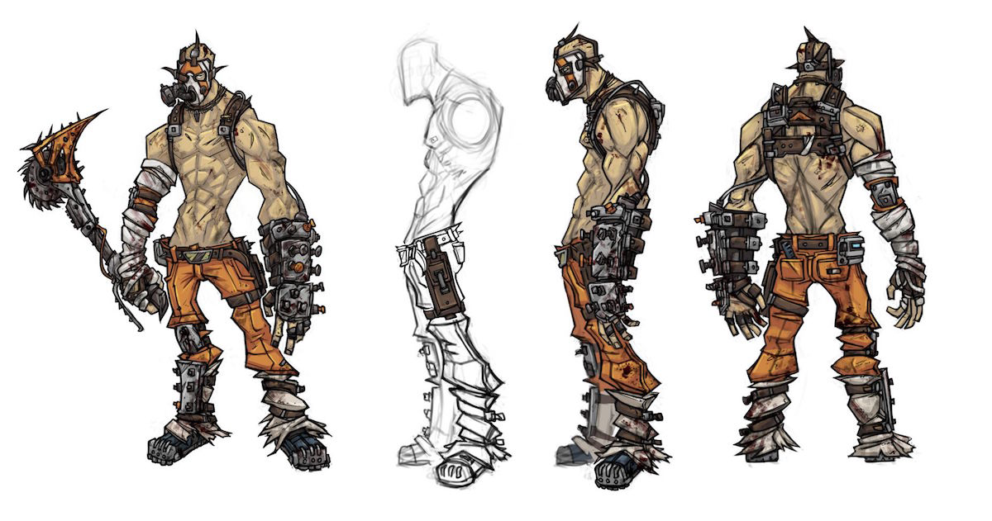](https://www.google.com/search?q=borderlands+progression+of+concept+art&rlz=1C1GCEB_enGB838GB839&source=lnms&tbm=isch&sa=X&ved=0ahUKEwiDu8Gj197iAhUAUBUIHdK4C2EQ_AUIECgB&biw=1536&bih=775#imgrc=kEY_ybajmL-AkM:)

# Mood/Feel

Concept artists control how the overall mood or feel of the artwork will be which will then later be made into the game portraying the same mood and feel. If a concept artist for a realistic game wanted to show misery and loss they would make all of the items in the game look battle scarred by adding dirt, grime and scratches making the viewer/player think that this world and the characters within it have gone through great trauma to have all of their belongings be worse for wear. With the addition of rust and dents to the items you can portray that the scavenging has been going on for a long time. To make a games mood seem happier an artist would use bright and vibrant colours.

We Happy Few is a game all about mood and about how you shouldn't judge something on first look. As if you take a glance at the concept art work for We Happy Few you'll think that the games mood is happy with the vibrant colours and smiling faces but on inspection you realise that the characters are merely wearing masks that force them to smile and underneath they are depressed. You also notice that there is blood and dead bodies around the happy few that the characters are oblivious too which gives off ominous tones of psychological trauma.

The advantages of having concept art that shows mood and makes the viewer feel the emotions that the artist wants, is that it will shape the game throughout the rest of the project as the developers will constantly be feeling the same emotions when looking at the concepts. A disadvantage to this is that it could change the game and make it progress in the wrong direction away from the original creator’s vision.

[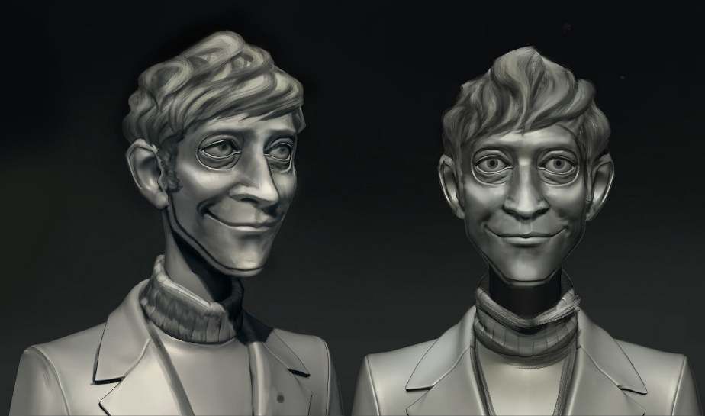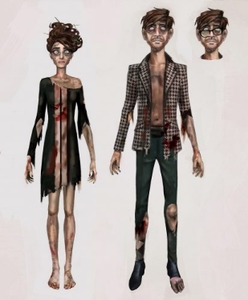](https://www.iamag.co/we-happy-few-70-concept-art-by-whitney-clayton/)

[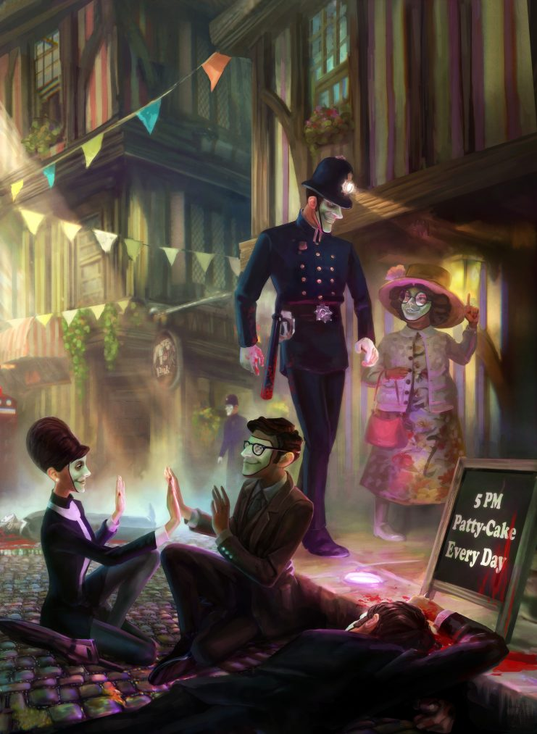](https://www.iamag.co/we-happy-few-70-concept-art-by-whitney-clayton/)

# Colour Schemes:

Colour schemes are an important aspect of concept art and games development as it can severely affect the tone, mood and feel of an art piece. As if your artwork contains cooler colours such as blue to purple on the colour spectrum it will make the player feel more cold emotions and distant from the artwork. Whereas if the colour scheme for the art piece is warmer containing colour from red to yellow on the colour spectrum it will remind the viewer of sunrise or sunset allowing for more warm-hearted emotions to be felt by the viewer. If the colour scheme of a games concept art consists of greys to black the artwork can be portrayed as a more expressionistic piece that uses symbolism and metaphors to portray physical things, concepts and emotions. Such as a black background could be portraying someone as feeling sad or depressed. An excellent use of a grayscale colour scheme used in video game artwork is in the indie title Limbo in this you play as a child shrouded in the darkness trying to find out what has happened from the perspective of this boy. The artist has used lighter greys and white to convey hope in this title by always having a part of the screen in the dim world be lit up so throughout the game you are traveling towards the light and escape the child's fears and demons.

An advantage of having the same colour scheme throughout a project is that the game will be able to stick with the same theme through all of the game as a games theme heavily relies on the colour scheme. For example, if you were playing a black and white game and the colour scheme sporadically changes to have colour it would disconnect the player from the game. A disadvantage of having the same colour scheme is that the game could look too similar throughout the playthrough with no real change boring the player

[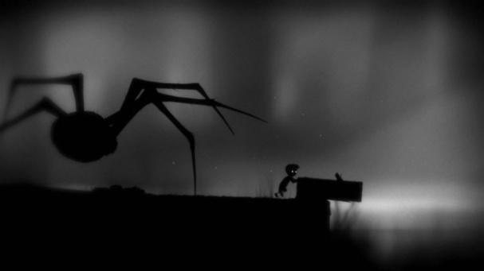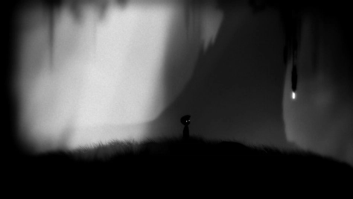](https://xboxeye.wordpress.com/2010/03/20/limbo-screenshots-and-concept-art-released/)

Artists

# Artists Introduction

In this report I will be exploring different artists and their specific art styles. The two artists I have chosen to make a report on are Satoru Takizawa, known for his works with the Zelda and Mario game series, and Ken Sugimori who is recognised mostly for his great artwork with the Pokémon franchise.

<https://kpcreativeweb.wordpress.com/2017/09/28/satoru-takizawa/>

-<http://nintendo.wikia.com/wiki/Satoru_Takizawa>

<http://kyoto-report.wikidot.com/satoru-takizawa>

http://www.imdb.com/name/nm0847702/

# Satoru Takizawa

[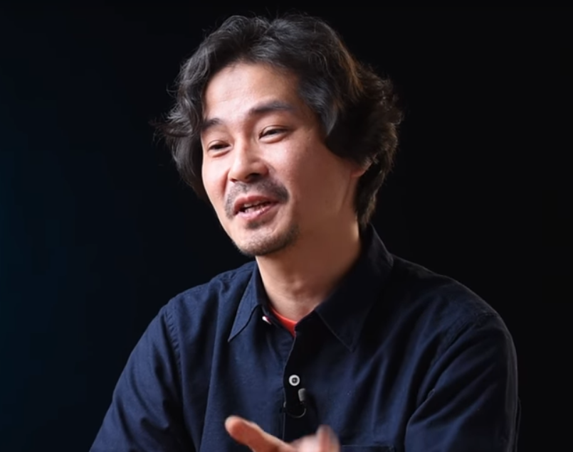](http://nintendo.wikia.com/wiki/Satoru_Takizawa)

## Summary

[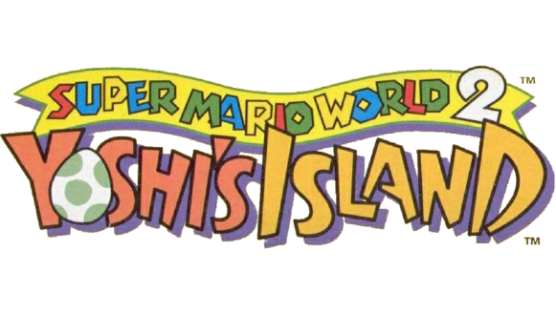](https://www.mariowiki.com/File:SMW2_Yoshi's_Island_Logo.png)Satoru Takizawa is a graphic designer currently working at Nintendo, Satoru was born in Nagano Japan in 1972, he started work at Nintendo around the time when the Nintendo 64 was released However he officially joined Nintendo in 1995. His first project while working with Nintendo was to design the logo for the international version of the SNES (Super Nintendo Entertainment System) video game Super Mario World 2: Yoshi’s Island. That means as soon as Satoru started work at Nintendo, which was when he graduated from Musashino Art University, he was already doing noticeable work. I believe Satoru Takizawa’s greatest achievement up to date is with the critically acclaimed game The Legend of Zelda: Breath of the Wild.

## History at Nintendo

Satoru started his artistic journey when he was a child as he was interested in drawing comics rather than playing games on the NES (Nintendo Entertainment System) unlike his childhood friends. The only time he ever got to play games was when he visited his friends’ houses as he himself did not own the system. After every comic made, he would pass it around in the household and at school to only hear praise as his family and friends were delighted by how good the comics were.

During college Satoru would work on his friend’s projects and develop CGI effects for them yet he still wasn’t interested in video games until he was introduced to the SNES (Super Nintendo Entertainment System) the upgraded version of the console he used to play at his friend’s house. He firstly played The Legend of Zelda: A Link to the Past and shortly new that he had to work at Nintendo as he saw the possible future videos games had. As you know Satoru achieved his goal of working at Nintendo and he first job was designing the logo for the game Super Mario World 2: Yoshi’s Island. With the release of the Nintendo 64 console Nintendo realised they needed people with a background in 3D design and as Satoru previously worked on 3D designs before, Nintendo turned to him. The company delegated Satoru with designing 3D models for the Super Mario 64 enemies including Klepto the Condor, Unagi the eel and the Manta Ray. [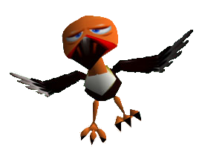](https://s-couting.deviantart.com/)[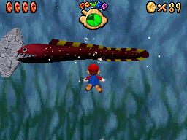](http://mario.wikia.com/wiki/Unagi)[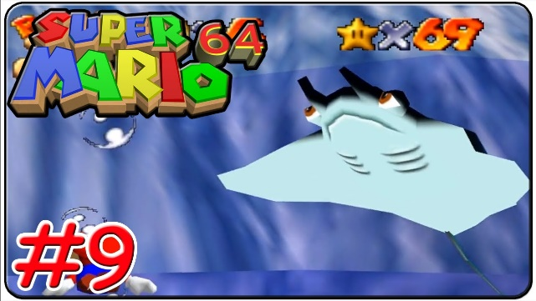](https://www.youtube.com/watch?v=1cha8zy1ahM)

The designs of Klepto the condor and Unagi the eel also made a surprise appearance in the new Mario game Super Mario Odyssey. Klepto the condor can be found in the lost world/ island when he steals Cappy from you and Unagi the eel can be found in Seaside Kingdom as a normal enemy trying to block you path.

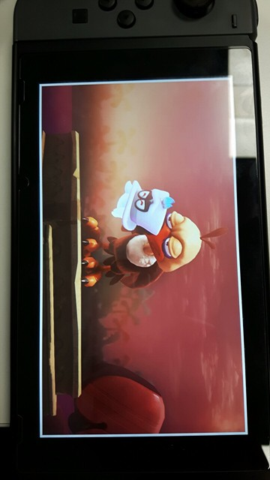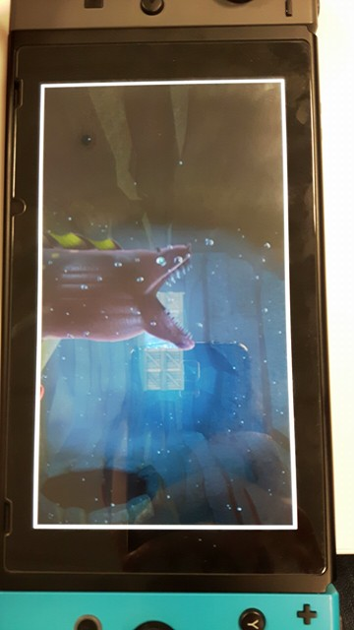

From his work with Super Mario 64 Satoru was assigned the task of creating many bosses and landscapes such as Goras in Titania, Bacoon in Aquas and a couple others. Apparently, the software Satoru Takizawa was using while making Star Fox 64 bosses was unheard of in the university he was attending.

Satoru Takizawa’s most important work with the Nintendo 64 console was designing the main antagonist in the game The Legend of Zelda: Ocarina of Time which is Ganondorf. Satoru did so well with the model he even earned Shigeru Miyamoto’s praise who is noted to be the greatest video game designer of all time by IGN. Satoru has contributed to virtually every game in the Zelda franchise with his most recent work as the art director for The Legend of Zelda: Breath of the Wild which is being viewed highly by critics achieving 10 out of 10’s all around.

[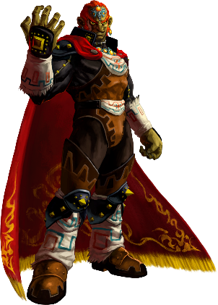](http://zelda.wikia.com/wiki/Ganondorf_(Ocarina_of_Time))

## Art style

Cartoon exaggeration – toon link

[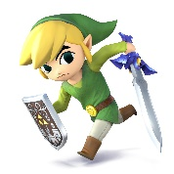](http://www.smashbros.com/us/characters/toon_link.html)When the Legend of Zelda: The Wind Waker was released players were astonished with the completely different design of their beloved hero Link as Toon Link well looks like a cartoon with the bright colours and exaggerated smallness of the revived character also with the big head and eyes on the small body. Many hated but at the same time a lot of people loved the new design of the character and thanked the art department of the game including Satoru Takizawa.

[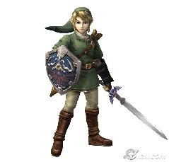](https://comicvine.gamespot.com/forums/battles-7/wind-waker-link-vs-twilight-princess-link-1824948/)However, with the upset of Wind Waker Satoru Takizawa tried a completely different approach with the character Link in the new game The Legend of Zelda: Twilight Princess as he was the art director for the game, so he decided to go for a grittier and darker realism for Link and the game to demonstrate the villain Ganon’s horrible reign on the Kingdom known as Hyrule. This new art style is truly shown throughout the design of Link as his tunic is a darker green, his sword is damaged and dark and well everything has changed even Link’s hair colour from a bright blonde to a dirty blonde like it has actual dirt in his hair from battle. But not all of the fan base for Zelda liked this link and though it was too dark.

So, Satoru made a compromise with the new game Legend of Zelda: Breath of the Wild by making Link look like the Twilight Princess Link mixed with the cartoon style of Wind Waker hoping that everyone will like Links new design to fit the fantastic game. Although I don't think Takizawa thought so many people would love the new design for Link and the game to the point that it won Game of the Year for 2017.

[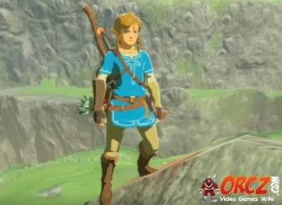](http://orcz.com/Breath_of_the_Wild:_Link)

<https://www.youtube.com/watch?v=cB8mi_Q2NKw>

<http://nintendo.wikia.com/wiki/Satoru_Takizawa>

<http://www.imdb.com/name/nm2242949/>

<https://bulbapedia.bulbagarden.net/wiki/Ken_Sugimori>

<http://pokemon.wikia.com/wiki/Ken_Sugimori>

<https://www.youtube.com/watch?v=5cdX-ekdpJ8>

<http://fuckyeahkensugimori.tumblr.com/>

<https://answers.yahoo.com/question/index?qid=20111013215602AAyumUM>

<https://en.wikipedia.org/wiki/Fanzine>

# Ken Sugimori

[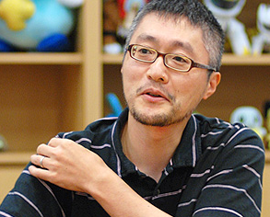](https://bulbapedia.bulbagarden.net/wiki/Ken_Sugimori)

## Summary

Ken Sugimori is a phenomenal illustrator, writer and animator, he is most known for his work with the massive Pokémon franchise. Ken Sugimori was born on the 27th of January 1966 and raised in Tokyo, Japan. Sugimori's first recorded work on a video game was with the SNES (Super Nintendo Entertainment System) title Smart Ball he worked in the animation department and the writing team with the game development company Game Freak. Ken Sugimori acquired his education from Tokyo National College of Technology where of course he studied electronics. [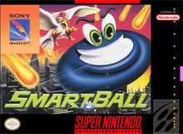](https://en.wikipedia.org/wiki/Smart_Ball)

## History

Sugimori used to illustrate gaming related fanzine's (A magazine in the shape of a fan) called Game Freak from early 1981 to 1986 they contained information on certain characters of a video game and their different moves. Sugimori shortly became friends with the creator of the fanzine Satoshi Tajiri even though he used to only do work on a freelance basis as Ken originally wanted to pursue a career as a manga artist. However, Sugimori's career path changed when he decided officially join Game Freak as an employee. Sugimori and Tajiri decided to change the company and pursue game development in 1989. As a new revived company Tajiri and Sugimori decided to pitch a new arcade game to the famous company Namco and produced Mendel Palace ADD PIC OF GAME. [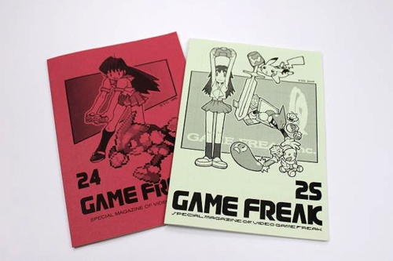](https://warosu.org/vr/?search_tripcode=!!2G3pb9QipZ2&offset=192&task=search2)[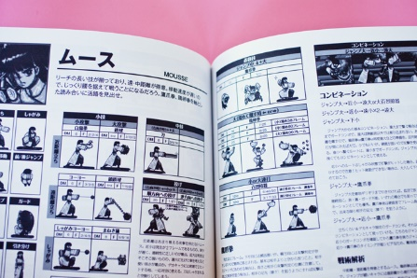](https://www.wired.com/2012/12/japan-gaming-doujin/)[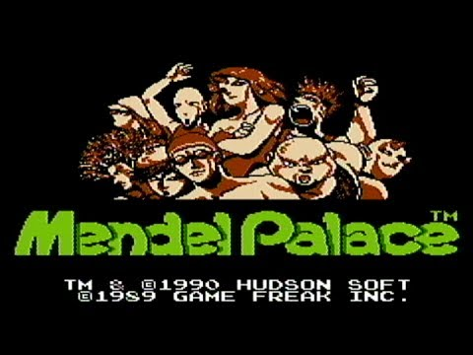](https://www.youtube.com/watch?v=O0xktbPxm8A)[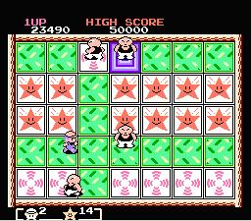](http://www.consoleclassix.com/nes/mendel_palace.html)

Ken Sugimori is mostly famous for creating the final designs for the original 151 Pokémon in Pokémon Red and Green created in 1995 with Atsuko Nishida, Motofumi Fujiwara and Shigeki Morimoto and released in Japan in 1996. Sugimori did the final designs for all of the Pokémon because the company wanted all the Pokémon to have a uniform style. Sugimori based his artwork for the pocket monsters on the in-game sprites as this was the only artwork they had for the characters. He has also worked on various Pokémon movies, trading cards, other fantastic games and Sugimori has also worked on many other manga. [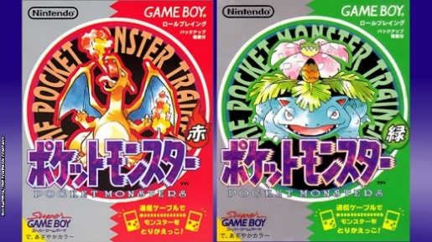](https://northatlanticblog.wordpress.com/2015/10/08/pokemon-lavender-town-syndrome/)

When Game Freak started developing Pokémon Black and White in 2010 Sugimori directed a team of 17 people to design new Pokémon and characters for the game. Sugimori's inspiration for the Pokémon in Black and White from observing animals in zoos and aquariums. Ken Sugimori has also done a few manga's (a Japanese comic) including an original which was a pre-order exclusive in the guide with the game Pokémon Mystery Dungeon: Explorers of Time and Darkness.

[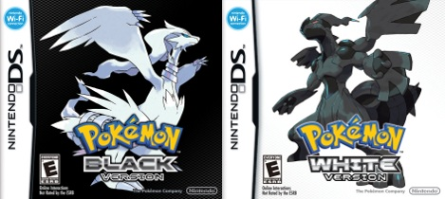](https://pokemondb.net/black-white) [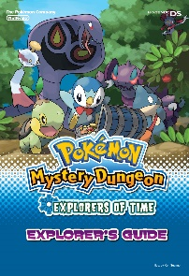](http://www.vgblogger.com/pre-order-alert-pokemon-mystery-dungeon-explorers-of-time-darkness/2714/)

Sugimori has a specific routine when designing new characters for a franchise firstly he will make a rough sketch then he will trace it onto film paper while adding detail, after that he will trace over the paper making a professional character. Often, he will change the proportions of the character until he is satisfied with his work.

## Art style

Ken Sugimori's art style is very infrequent and constantly changes depending on what he is working on, such as for the Pokémon game franchise he uses pixel art as that is the only way they could represent art on the outdated Gameboy and or Gameboy colour. His pixelated art is outstanding, and this is proven as it captured the heart of millions when playing the original Pokémon games. [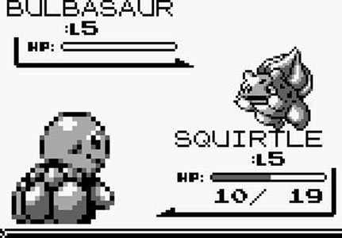](http://gameluster.com/pokemon-red-and-blue-review/) [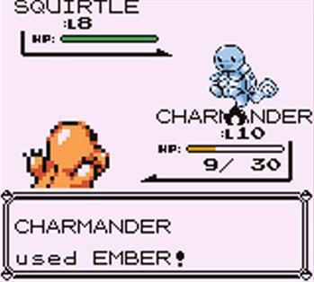](http://mancunion.com/2016/03/14/pokemon-review/)

Ken Sugimori also uses the manga art style as he used to want to be a manga artist before he started designing games, but he still incorporates manga into his work now as you can see from the picture of Charizard, Ash and his rival, Sugimori still uses his classic watercolour art style and relates it to Pokémon. Sugimori’s water colour paint art style shines through in his work as it precisely displays his imagination and intended picture he wanted the reader to see.

[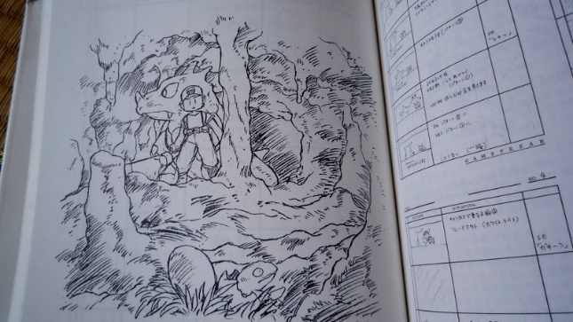](http://www.pepinismo.net/libros-sobre-pokemon/)[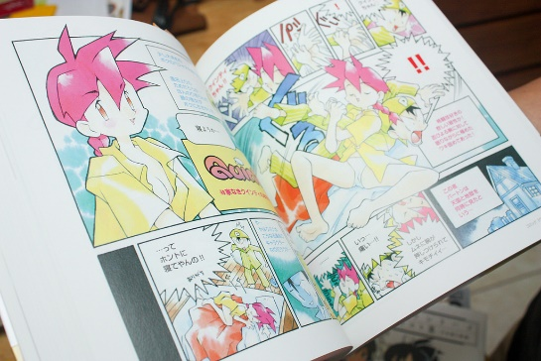](http://pokemon.wikia.com/wiki/File:SugimoriQcover.jpg)[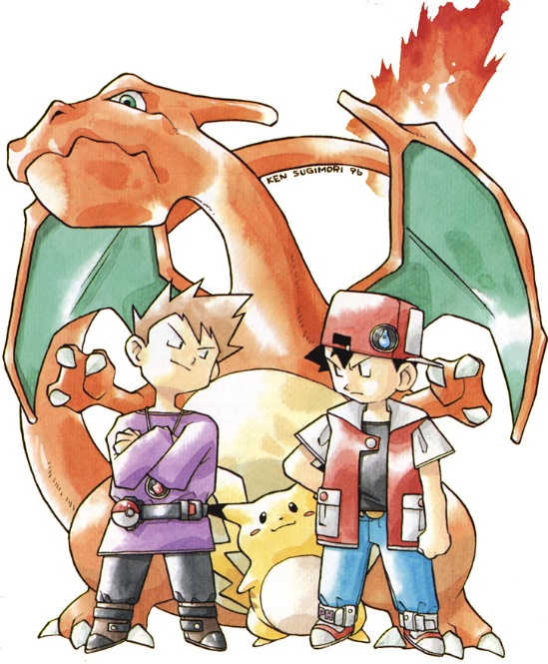](https://www.pinterest.com/pin/236579786645693277/)

With Pokémon as a franchise becoming so popular an anime was created which was called Pokémon Indigo League and in the animation department for this show was the Ken Sugimori and that is clearly seen in the art style for the show as it looks just like Sugimori’s old water colour manga’s just without the water colour and with bold thick paint colours. This is shown truly with the character Misty in the television show compared to a female character in one of Sugimori’s manga’s they look almost exactly alike with the same straight lines representing their chins.

[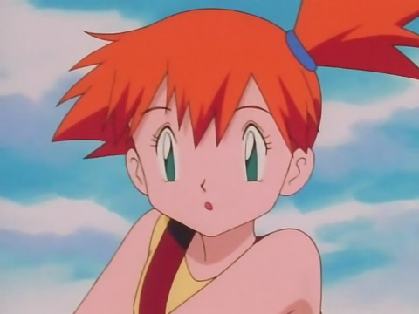](http://www.j-opolis.net/sections/television/ashmisty_3.html)[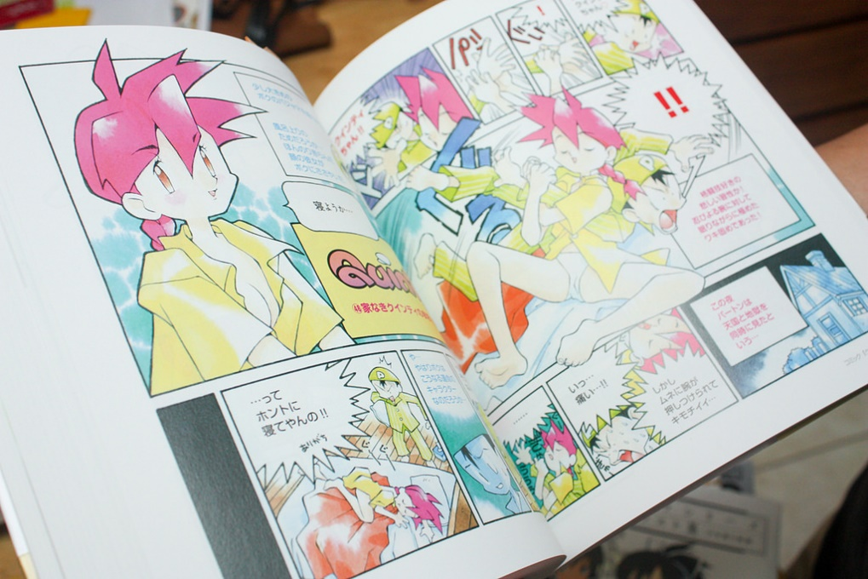](http://pokemon.wikia.com/wiki/File:SugimoriQcover.jpg)